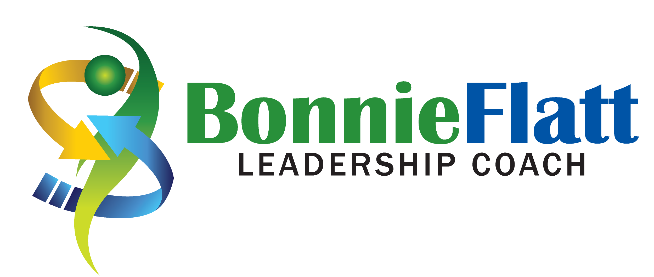
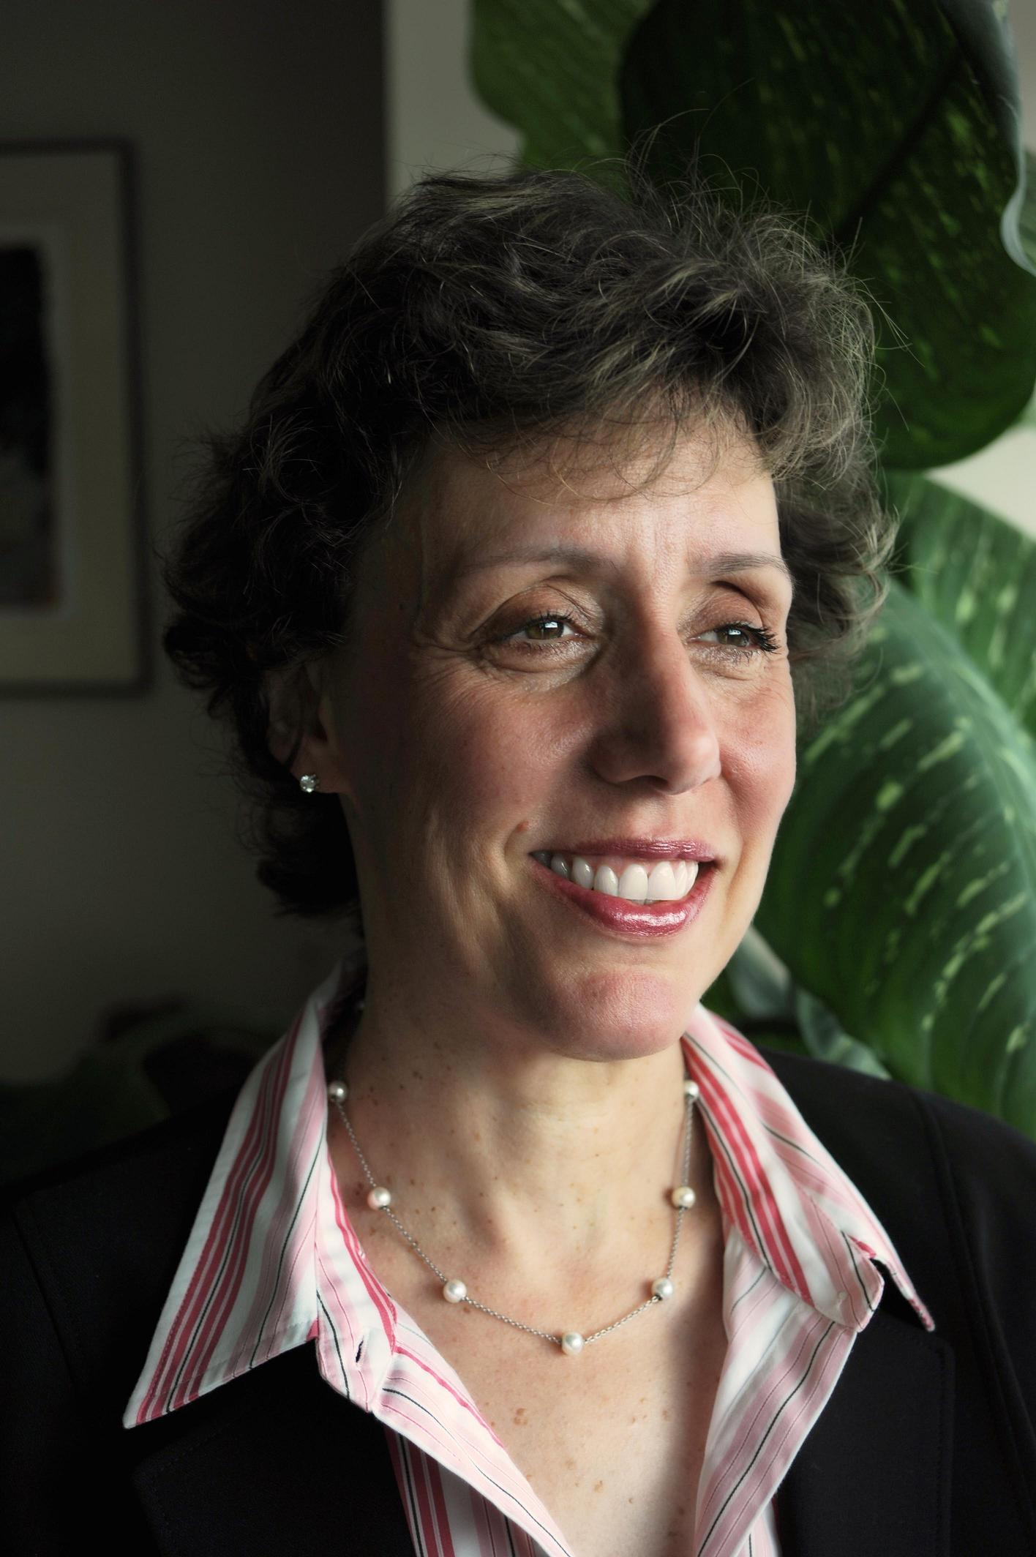

Bonnie Flatt, LLB, CPCC, ACC, SHRP
19 Marchwood Drive, 647-205-7879
Toronto, Ontario, Canada M3H 1J7 bonnie@bonnieflatt.com

Overview
Bonnie is passionate about building collaboration and creativity in the workplace to drive organizational results. She works with individuals and teams, as well as boards of directors to understand and align on their purpose and values and develop goals and outcomes that deliver meaningful results. Her purpose is to liberate the human spirit in each of us as leaders and to bring joy, fun and love back to work. She stands for the greatness of her clients and creates the space for their success.
Bonnie works as a facilitator, executive coach and consultant. She has over 25 years experience, working with hundreds of leaders and board members to bring about transformational change.
Experience
Prior to starting her own leadership coaching and HR consulting practice, Bonnie was an HR executive at MDS Inc. and a principal at Mercer and Vice President at PricewaterhouseCoopers LLP, where she consulted to major Canadian global companies in healthcare, life sciences and technology. She focused on leadership development, employee engagement and the alignment of pay and performance. Representative clients included GSK, Aviva, TD Bank and Nortel.
Areas of Expertise
Bonnie designs and delivers individual and group coaching and leadership development programs that transform how her clients work together to drive results. Recent workshops covered topics such as team dynamics, dealing with conflict, creating a vision and tribal leadership. In her volunteer capacity on not for profit boards, Bonnie facilitates and creates the space for all voices to be heard and to build strong relationships between management and the board.
Personal
Bonnie is a lawyer by training and a certified leadership coach by calling. She lives with her husband and 2 teenage children in Toronto Canada. She loves theatre, travel, writing and meeting new people. Her hobbies include cycling, reading and volunteer work.
In her spare time Bonnie speaks and writes about leadership and talent management. She has been featured in the press and spoken at human resource conferences. Bonnie is a member of the board of directors of Covenant House and previously was a board member for the MS Society of Canada, Delisle Youth Services and Bialik.

Bonnie has a B.Sc. from the University of Toronto and a LL.B. from Queens University. She is a graduate of the Coaches Training Institute and certified executive coach with the ICF. Bonnie recently earned the designation of Approved Tribal Leader and is a senior human resource professional (SHRP designation) with the HRPA.

